Schedule Change – Opportunities from the backlog
Backdrop: Understand → Ideate → Prototype → Test → Decide

Understand
To begin with, let’s look at the top 5 highest-impact problems hidden in the backlog:
Based on all the ADO product backlog (Enhancements + Tech Debt / Break-fix / Maintenance items), here are the five underlying problems (not solutions):

Problem 1 – Eligible customers are blocked from self-service
Many items are about:
- SC eligibility (alternate OD / routing / infant in lap)
- Impacted segment identification (drss remarks)
- Time rule calculation bugs / connection time checks
Hidden problem:
Customers who should be able to self-serve schedule changes are misclassified as ineligible, forcing them to call or abandon.

Problem 2 – Customers struggle to find and choose acceptable alternate flights
Items like:
- Choose Flights Matrix (slice title, date carousel, alternate flights, filters + result count)
- Placeholder screen for matrix
- “No flights available” messaging
- Order trip updates based on flight card content
Hidden problem:
Even when customers are eligible, the UI for choosing new flights is confusing or incomplete, making it hard to understand options and leading to drop-offs or calls.

Problem 3 – The SC flow is fragile due to tightly coupled, error-prone services
Items like:
- SPIKE: decouple alt-flights, rebook and PTOL from Dynamic Rebooking
- SPIKE: Simulate 503s for AVP in non-prod
- Flight Status API disruption message testing
- SC errors / null pointer spikes
- FIFO API changes, drss-alt-flight service usage
Hidden problem:
The technical architecture for schedule change is brittle; when one dependent service hiccups, the whole SC experience degrades or fails.

Problem 4 – Lack of visibility into customer behavior and system performance
Items like:
- Analytics for missing elements
- Track analytics for Cancel Trip action on SC screen
- Dynatrace dashboard for SC eligibility
- SC PNR generator
- Documentation for optimizing SC welcome screen
Hidden problem:
The team doesn’t have enough data/observability to see where customers struggle or where defects occur, making prioritization and learning guess-y.

Problem 5 – Complex disruption scenarios are handled inconsistently
Items like:
- Check connection time between segments
- Testing: Connection Airport & Time Change (Part 1 & 2)
- SC after XPT
- SC eligibility: routing/ROD changes post-SC
- OSI removal, impacted segment identification, flight status disruption
Hidden problem:
In more complex disruption scenarios (connection, airport/time changes, rerouting), SC logic and UX don’t consistently present correct, understandable options—creating confusion and manual work.
Recommendation: Aling on a product goal/Objective:
e.g. Increase successful self‑service schedule changes for impacted customers and reduce SC‑related calls

Ideate

Opportunity 1: Fix eligibility misclassification so more truly eligible customers can self‑serve
Solution ideas / existing work:
- SC eligibility: allow PNRs with alternate O/D post‑SC to self‑serve (Phase 1)
- SC eligibility: allow PNRs with routing/ROD change post‑SC to self‑serve
- SC Eligibility: infant in lap PNRs
- SC Eligibility: time rule calculation & incorrect determination bug fixes
- Impacted segment identification in drss‑remarks‑service (Part 2)
Key measure: % of impacted PNRs that qualify as eligible AND complete self‑service

Opportunity 2: Make it easy and clear for customers to browse and select alternate flights
Solution ideas / existing work:
- Choose Flights Matrix: slice title, alternate flights matrix
- Choose Flights Matrix: date carousel
- Choose Flights: filter by + result count
- Show “No flights available” message on selected date
- Placeholder screen for Choose Flights Matrix
- Order trip updates based on flight card content
Key measure: drop-off rate and time-to-complete on Choose Flights step

Opportunity 3: Improve reliability and resilience of the SC flow
Solution ideas / existing work:
- SPIKE: decouple alt-flights, rebook, PTOL from Dynamic Rebooking
- SPIKE: Simulate 503s for AVP in non-prod
- FlightStatus API update – disruption message no-harm testing
- FIFO API changes + drss-alt-flight FIFO usage / implementation
- Spike: SC errors: null pointer exception
Key measure: SC error rate (500s, NPEs, timeouts) and impacted sessions

Opportunity 5: Handle complex disruption scenarios consistently and clearly
Solution ideas / existing work:
- Check connection time between segments when limited original/updated flights
- Testing: connection airport & time change (Part 1 & 2)
- SC after XPT flow improvements
- OSI removal in self-serve flow
- FlightStatus / impacted segment logic aligned with SC rules
Key measure: completion rate and CSAT/NPS for customers with complex disruptions

Prototype, Test, Decide

Example on Opportunity 5:
Understand → Ideate → Prototype → Test → Decide

Sample Discovery Plan (Opportunity 5): Improve Complex Disruption Handling in Schedule Change (SC)
Why This Matters
Complex disruptions represent the highest-friction segment of SC, responsible for:
- Incorrect eligibility classification
- Confusing or missing options in Choose Flights
- High error rates due to tightly coupled backend services
- Inconsistent data (impacted segment logic, routing mismatches)
- Disproportionate agent workload and customer frustration
Fixing this area yields significant customer and operational impact.
We understood the problem, now we’ll focus and define a goal or Objective with KRs to Ideate-prototype-test-decide.
Objective
Deliver a consistent, reliable, and intuitive schedule-change experience for customers facing complex disruptions (connection time changes, airport/time shifts, ROD/OD changes, routing changes, XPT transitions).
This reduces confusion, abandoned flows, and contact center reliance.
Draw Key Results
KR1- Increase self‑service SC completion rate for complex disruptions from X to Y
KR2- Reduce SC‑related calls from customers with complex disruptions by X%
KR3- Reduce eligibility misclassification for complex scenarios by X%
KR4- X% reduction in technical failure rate in complex flows
KR5- Improve customer clarity in complex disruption flows, reduce drop‑off rate on steps impacted by connection/airport/time changes (Choose Flights > Matrix > Confirmation) by X%

Expected Impact
- More customers handle disruptions independently → higher satisfaction.
- Meaningful reduction in agent load and manual rebooking effort.
- Stronger reliability across SC architecture.
- Clear, explainable decision paths that increase trust in the experience.
- Improved predictability and speed for future SC enhancements.

Draft
Ideate on focus Areas
1. Clarify/Understand the user needs
- Segments with complex disruption scenarios (connections, airport/time, ROD/ROD, XPT, routing mismatches).
- Quantify how often each occurs and where customers drop off.
- Map the end-to-end SC flow for these scenarios to identify failure points.
- Conduct targeted interviews with frontline agents to capture customer pain signals.
2. Identify Opportunities (Problem Statements)
- Customers can’t understand what changed or why they see limited flight options.
- Eligibility misclassification blocks customers from self-serving.
- Service coupling and brittle logic create errors in the most complex scenarios.
- Missing instrumentation hides where experience fails.
- Placeholder screens and unclear messaging erode trust.
3. Hypothesize Where We Can Move the Needle
Examples:
- If impacted segments are correctly identified, more customers will be eligible and complete self-service.
- If the UI clearly explains complex changes, fewer customers will abandon.
- If core services are decoupled, SC errors will reduce.
- If empty/low-options scenarios are designed intentionally, trust increases.
4. Prototype & Test Quickly
- Figma prototypes to validate comprehension of complex change messaging.
- Technical simulations (503s, mismatched itineraries, DRSS variants) to address system fragility early.
- Lightweight instrumentation to establish baselines for complex disruption behavior.
5. Evaluate & Prioritize Based on Evidence
Use impact × confidence × effort × risk to select what moves to delivery.
Expected early priorities:
- Impacted segment identification
- Eligibility logic for complex scenarios
- Reliability work (service decoupling)
- UI clarity for complex cases
Success Metrics (aligned to OKR)
- Increase SC completion rate for complex disruptions by 20–30%.
- Reduce SC-related call volume by 15–25%.
- Reduce eligibility misclassification by ~80%.
- Cut SC error rate (503s/NPEs/timeouts) by ~50% in complex flows.
- Lower drop-off in Choose Flights for complex disruptions by 20%.
These metrics anchor solutions in outcomes vs. output.
Expected Impact
- More customers handle disruptions independently → higher satisfaction.
- Meaningful reduction in agent load and manual rebooking effort.
- Stronger reliability across SC architecture.
- Clear, explainable decision paths that increase trust in the experience.
- Improved predictability and speed for future SC enhancements.

User Stories need improvement
E.g. https://dev.azure.com/AmericanAirlines/ServiceRecovery/_workitems/edit/2523225
Discover:
How might we reliably differentiate SC-driven changes from voluntary changes across all complex disruption paths?
Add a problem statement up top:
Add problem: “Customers who had a schedule change followed by a voluntary change cannot view their SC history and instead see an error. This prevents them from understanding what changed, increases anxiety, and often results in calls to support.”
This reframes the story from system mismatch → customer confusion.
User Story:
As a customer who clicks the “Schedule Change” banner after making additional changes to my trip,
I want the system to show me a readable history of the original and updated flights from the last schedule change event (even if my current itinerary has since changed),
so I can understand what the airline changed versus what I changed, and avoid confusion or unnecessary calls
Details:
- Backend:
  - If CS Retrieve itinerary does not match the SC history record:
    - Use OSI timestamp and SC.REA data to reconstruct original + updated segments for the last SC event only.
  - Return this as a structured “SC History View Model” to the UI.
- Frontend:
  - Display that SC history (original vs updated flights) in the existing history UI pattern.
  - Show a basic neutral message using a placeholder copy approved by UX or product for this sprint, e.g.:
“These changes occurred as part of a schedule change. Your current itinerary may differ.”
Splitting this further:
Slice 1 – Stop failing; show something useful instead of an error: Replace the error with a basic, accurate SC history in the mismatch scenario
Slice 2 – Improve clarity: distinguish SC-driven changes from current itinerary: Help customers understand why what they see in SC history may differ from what they see in their current itinerary.
Slice 3 – Handle common multi-segment cases (partial mismatch): Support more realistic itineraries where only some segments changed after the SC.
Slice 4 – Guardrails & Observability: Make sure we can monitor and iteratively improve this behavior.
Slice 5 – Experience refinement (post-learning): Refine UI/UX once we’ve learned from real traffic and qualitative feedback.

|
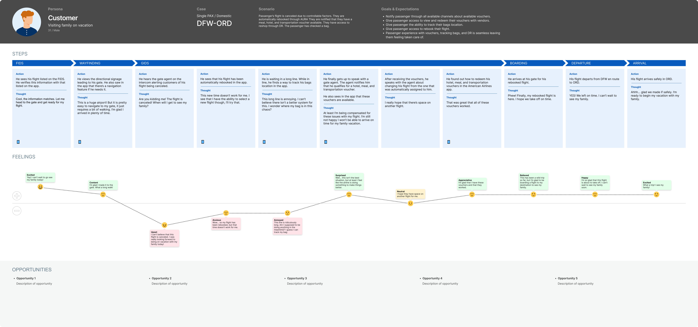

1. UNDERSTAND
The Problem
Complex disruption scenarios (connection-time changes, airport/time changes, reroutes, ROD changes, XPT flows) produce inconsistent logic and confusing customer experiences across SC, DRSS, FlightStatus, and OSI services.
Evidence (from backlog + patterns):
- Connection-time logic fails or varies
- SC after XPT leads to dead ends
- DRSS impacted-segment logic misclassifies
- FlightStatus rules not aligned with SC eligibility
- Customers frequently abandon or call during disruption flows
Why It Matters
- “Moments of truth” where customer stress is highest
- Heavy driver of call volume + manual rework
- Degrades trust in self-service
- Slows IRROPS recovery
Product Goal
Increase successful self-service SC completions for customers with complex disruptions while reducing SC-related calls.
Key Outcomes
- Higher completion rate for complex disruptions
- Improved NPS/CSAT
- Reduced disruption-related SC calls

2. IDEATE
How might we create a clear, consistent, trustworthy SC experience during complex disruptions?
Concepts (not solutions):
- Unified logic across SC, DRSS, FlightStatus, and OSI
- Guided UX that explains what changed and why
- Scenario simulation tools using synthetic PNRs
- Guardrails to prevent contradictory or invalid options
- Analytics instrumentation for disruption-specific drop-offs and errors
Coaching Tip:
Generate multiple viable approaches before narrowing. Discovery ≠ solutionizing.

3. PROTOTYPE
Purpose: Learn quickly, cheaply, and de-risk the idea.
Prototype Types:
- Guided Disruption UX Prototype (Figma)
  - Explain: what changed, why it changed, and what options exist
  - Test comprehension + confidence
- Logic Sandbox Prototype (Engineering)
  - Compare SC vs DRSS vs FlightStatus during disruptions
  - Reveal mismatch scenarios + fragile logic
- Analytics Spike
  - Instrument 1–2 critical events (e.g., “no valid alternates”)
  - Validate observability gaps
- Chaos/Scenario Simulation
  - Simulate ROD, airport/time changes, connection downgrades
  - Validate resilience of unified logic
Coaching Tip:
Prototypes are for learning, not shipping.

4. TEST
Validate the riskiest assumptions.
Riskiest Assumptions:
- Customers can understand and act confidently during complex disruptions
- Unified logic will produce consistent, predictable options
- Engineering can reliably reproduce disruption scenarios
- Observability is sufficient to guide decisions
Testing Methods:
- Customer testing: Guided-flow usability interviews
- Logic testing: Compare sandbox vs real outputs → reduce mismatch rate
- Chaos testing: Validate robustness across disruption types
- Analytics validation: Confirm new instrumentation captures real friction points
Success Indicators:
- Higher comprehension + reduced confusion
- Lower mismatch rate across services
- Fewer “dead ends” in SC flows
- Stronger observability

5. DECIDE
Use evidence to make an informed product decision.
Go If:
- Customers understand the flow
- Unified logic improves consistency
- Error cases reduce significantly
- Data shows improved completion & fewer calls
Pivot If:
- Customers still struggle to understand disruptions
- Logic alignment is partially successful
- Additional observability needed
Kill If:
- No measurable improvement in completion or call reduction
- Complexity outweighs customer / business value
Expected Impact (if Go):
- More disrupted customers self-serve successfully
- Fewer calls + less agent rework
- Faster recovery during IRROPS
- Increased trust in AA digital experiences

